SPRING WOLF & BEAR DISCOVERY
Package Itinerary & Details
Spring/Summer 2021

The Spring Wolf & Bear Discovery Lodging & Learning package is designed for those who want to focus on observing wolves and bears in the wild while learning what we presently know about these fascinating species. The package is offered by Yellowstone National Park Lodges, covering lodging arrangements and some meals, with Yellowstone Forever providing educational programming.

Each morning your naturalist instructor will drive you to locations where the most recent wolf and bear activity has been reported. If we encounter other wildlife species along the way, you’ll learn the role they play in the ecosystem in relation to wolves, elk, and more. Early afternoons will be spent exploring the animals’ habitats on short hikes in search of tracks and sign. Your instructor will facilitate informative discussions about current research and management of these amazing species. Every late afternoon you’ll return to Mammoth Hot Springs, giving you plenty of time to relax, have dinner, and enjoy the surroundings.

All lodging is based at Yellowstone National Park Lodges’ Mammoth Hot Springs Hotel.

Program Highlights
- Three full days searching and observing wildlife in Lamar Valley, along Yellowstone’s northern range and elsewhere in the park
- Opportunities to engage with National Park Service biologists and researchers in the field
- In-depth focus on wildlife biology, ecology, and behavior
- Thought-provoking discussions related to the most recent research findings and management issues

Why Choose a Lodging & Learning Package?
Our award-winning Lodging & Learning packages are developed through a partnership with Yellowstone National Park Lodges. These packages combine the best lodging locations with an exceptional immersive field education experience. Here’s why this package stands out:

- Yellowstone Forever is Yellowstone National Park’s official nonprofit education and fundraising partner. Our mission is to partner with Yellowstone National Park to create opportunities for all people to experience, enhance, and preserve Yellowstone forever. To learn more about Yellowstone Forever, visit our website.

- You’ll help preserve Yellowstone. Proceeds collected by Yellowstone Forever for this package are used to preserve Yellowstone National Park and provide more opportunities for people to experience its magic. To learn more about what we do, visit our website.

- Our naturalist instructors are world class. The Yellowstone Institute has been providing in-depth educational programs in Yellowstone for over 40 years. Our naturalist instructors are among the best expert field educators in Yellowstone. They’re professionals with academic credentials who are dedicating their careers to this vital work. They live in the Yellowstone ecosystem, they work alongside park researchers, and thus can provide accurate and exciting “behind the scenes” perspectives on the park’s history, management, geology, flora, and fauna. They know where to go and when, and they’ll handle all the details to make your experience is as enjoyable as possible.

The same naturalist instructor will lead this program from the orientation on the first day to the final farewells on the last day. They’ll go out of their way to get to know you throughout the program, and make sure your needs are met. They’ll build upon what you’ve learned each day, so you can better understand the fascinating story behind everything you see and experience.

- Small group size. Typically this program has a max capacity of 13, however, due to Covid-19 safety precautions this program has been limited to 9 participants (up to 12 same family). You’ll enjoy camaraderie with fellow participants and receive a lot more attention in this small group package. It allows your instructor to take an inquiry-based approach to learning, tailoring the experience to your specific interests.

- We provide the essential equipment. Your instructor will provide high-quality digiscoping equipment to bring distant wildlife into crisp, clear view. We also provide snowshoes or safe travel over snow and ice on daily hikes. Our naturalists are Wilderness First Aid or Wilderness First Responder certified. They carry a first aid kit and handheld radio during all hikes and provide bear spray if hiking in bear country. They will incorporate teaching aids such as skulls, tracks, pelts, books, I-Pads with videos, and test equipment such as temperature guns for thermal features.

- You can’t beat in-park lodging. All lodging in this package is in the park, within short walking distance from popular features and spectacular scenery. This minimizes drive time during daily outings and allows more time to enjoy the park’s features at a relaxing pace. It also allows more time in the evenings, after daily outings, to relax and enjoy the beautiful surroundings.

What’s Included?
- 4 nights lodging in a Mammoth Hot Springs Frontier Cabin (lodging upgrades may be available)
- Most meals, to include:
  - 4 breakfasts to go
  - 3 deli lunches to go
- Hot beverages and snacks on the road
- Instruction by a Yellowstone Forever naturalist instructor throughout the program
- A custom 32 oz. Nalgene Tritan wide mouth bottle (gift item)
- Field equipment as needed
- An orientation on the evening of the first day to assure you will have an enjoyable and comfortable experience throughout the program.

Gratuities for your Yellowstone Forever naturalist instructor are not included, but are recommended and greatly appreciated.

How fit do you need to be?
This program is rated Level 2 on Yellowstone Forever’s Activity Level Scale. You should be prepared to hike up to 3 miles per day comfortably with elevation gains of up to 600 feet. Some off-trail hiking is possible. Most hikes will take place at elevations between 6000 to 7500 feet. Participants residing at lower elevations may want to arrive a day early to adjust to the altitude. To learn more about how specific medical conditions can be affected by Yellowstone's environment and our activities, please visit our site page on health information.

All field activities will be conducted as a group. If you cannot participate in the day’s activities, please let your instructor know in advance.

To participate in this program, each participant must fill out and sign our health questionnaire and assumption of risk waiver. Registrants receive a link to this form in their confirmation letter which is sent via e-mail. These forms must be completed and returned at least 30 days prior to your program start date.

Program Itinerary

The itinerary is designed to take advantage of the best opportunities in the park, but may be adjusted to adapt to weather conditions, wildlife activity, holidays, and road construction.

Day 1 Welcome and Orientation
After checking in and enjoying dinner, you’ll meet your naturalist instructor for an orientation. The instructor will go over the program itinerary, discuss clothing and equipment needed for daily outings, and answer any questions you may have about your upcoming adventure.

4:30 p.m. Mammoth Hot Springs Hotel Check-in Begins
Ask front desk staff for directions to the orientation room
7:00 p.m. Orientation in Mammoth Hot Springs
Dinner on your own
Overnight at Mammoth Hot Springs

Days 2 - 4 Wildlife Watching and Exploring Habitat
Each day begins early to catch the morning wildlife activity. Wolves and bears tend to be most active in the early morning. Mountain goats, moose, bison, elk, bighorn sheep, and birds continue to be active later in the day. After viewing wildlife, your naturalist will lead a short hike in wildlife habitat in search of tracks and sign while discussing ecology, behavior, recent research, and management topics.

6:00 a.m. Depart for wildlife watching
Hot beverages (coffee, tea and hot cocoa) and box breakfast in the field
Roadside viewing animals that are most active in the morning
Search for other wildlife species when morning activity dies down
Deli lunch in the field
Afternoon hike in wildlife habitat
3:00 p.m. Return to Mammoth Hot Springs
Dinner on your own

Day 5 Check Out and Departure
(To go breakfast included on checkout day.)

Cancellation and Refund Policy
For Lodging & Learning Packages, 50% of package cost is due at time of booking with remaining balance due upon arrival. A 30-day notice is required to receive full refund of your deposit amount. Cancellations made within 30 days of arrival will result in 100% forfeiture of deposit amount.

We strongly recommend the purchase of travel insurance to help protect you against financial loss if you must cancel or interrupt your trip due to unforeseen circumstances. For more information about travel insurance, please ask our representative when booking your reservation.

Covid-19 Health & Safety

Yellowstone Forever continues to adopt appropriate sanitization measures as prescribed by the Centers for Disease Control and Prevention (CDC) and encourage you to refer to this respected resource as you make your own near-term travel plans.

Our organization is in frequent contact with local authorities and partners such as county health departments and the National Park Service to continually monitor the situation on a regional level. We are closely monitoring government policy changes, CDC guidelines, government mandates, and public health advancements, and will continue to make changes as necessary and appropriate to our operations.

COVID-19 guidelines for program participants:
- Stay home if you are feeling any COVID-19 symptoms.
- At orientation each participant will be asked these screening questions. If you answer “yes” to any of these questions you will not be permitted to attend a Yellowstone Forever course.
  - Have you had a fever of over 100.4 °F or experienced shortness of breath or coughing in the last 10 days?
  - Have you come in contact with any individual known to have tested positive for COVID-19 within the last 14 days?
- Each participant will have their temperature taken upon arrival of each program day. If a participant has a fever, they will not be permitted on the program.

General Equipment and Clothing List
Much of your time will be spent outdoors, and you should be prepared for a variety of mountain weather conditions and temperatures. Appropriate clothing, equipment, and footwear are very important. Spring, summer, and fall temperatures can range from below freezing in the mornings to 85 degrees Fahrenheit in the afternoons. The layered use of garments for protection against the wind, sun, and temperature extremes should guide your clothing choices.

Equipment:
*Your instructor will be carrying a first aid kit, bear spray, and emergency communication device.
- Mask, facial masks will be required to wear in all vehicles and where social distancing cannot be adhered to.
- Hand Sanitizer
- Daypack, with enough capacity to carry extra clothes, water, lunch, camera, binoculars, etc.
- Water bottle. You will receive a 32 oz. Nalgene Tritan wide mouth quart water bottle as a gift during the program orientation. You should always keep a minimum of one quart of water on hand to facilitate proper hydration.
- Sunglasses
- Sunscreen/lip protector. Sun at high altitude can burn unprotected skin quickly.
- Camera, binoculars

Summer clothing:
- Insulating underwear, capilene, polypropylene, wool, or similar wicking fabric.
- Mid-weight insulating layer, a light synthetic fleece or wool shirt/pullover
- Heavyweight insulating layer, wool, down, or heavy-weight fleece jacket
- Waterproof and windproof outer layer, lightweight and breathable, jackets and pants
- Short-sleeve shirt, cotton is okay in summer, but synthetic wicking shirts are ideal.
- Pants, synthetic hiking pants. Jeans are not recommended.
- Hats, both a brimmed sun hat and an insulating hat for cool weather.
- Gloves, lightweight glove liners and a pair of wool/fleece gloves or mittens.
- Socks, specifically designed for hiking, that wick moisture
- Hiking boots that provide stability and traction. Make sure they are broken in, comfortable, and do not cause hot spots or blisters.
- Off-duty shoes, sandals, athletic shoes, or other leisure footwear.

Park Stores

Yellowstone Forever park stores feature more than 900 books, maps, and videos to help you plan your visit, along with a wide selection of shirts, hats, and other logo items to remind you of your visit to Yellowstone. Yellowstone Forever supporters receive a 15% discount on merchandise online or at any of our locations in and around Yellowstone. Proceeds directly support Yellowstone. Visit: shop.yellowstone.org

Supporter Program
Yellowstone Forever Supporters directly fund priority park programs and projects. Supporters also provide scholarships for teachers and help expand programming for underserved youth. Benefits include a subscription to our magazine Yellowstone Quarterly, early registration and discounts for Yellowstone Forever Institute programs, and discounts on Yellowstone Forever Park Store purchases throughout Yellowstone (exclusions apply). If you are not yet a supporter of Yellowstone Forever, an introductory membership (one year) to Yellowstone Forever is included with your tuition. For more information, visit: Yellowstone.org/donate.

Yellowstone Forever Supporters, and additional registrants who are staying in rooms occupied by a Yellowstone Forever Supporter, each receive a $15 discount on this package. A valid Yellowstone Forever Supporter card must be presented at check-in to receive this discount. This discount cannot be applied retroactively after initial check-in. We encourage all registrants to join online to take advantage of this discount and all of the benefits available to Yellowstone Forever Supporters.

Suggested Reading
No prior reading is required, but you might want something to occupy your flight or car ride. Most publications are available from Yellowstone Forever’s online Park Store at www.Shop.Yellowstone.org/ or by calling 406.848.2400. Yellowstone Forever supporters receive a 15 percent discount and proceeds directly support the park.

- Bear Attacks: Their Causes and Avoidance. Herrero, S. 1985. Nick Lyons Books, Winchester Press, New Century Publishers, Inc. Piscataway, NJ

- * Decade of the Wolf: Returning the Wild to Yellowstone. Smith, D.W. and G. Ferguson. 2005. Lyons Press, Guilford, CT

- Searching for Yellowstone: Ecology and Wonder in the Last Wilderness. Schullery, P. 1999. Houghton Mifflin Co., New York, NY

- The Bears of Yellowstone. Schullery, P. 1980. Yellowstone Library and Museum Association, Yellowstone National Park, WY 82190. ISBN: 0-934948-00-1.

- Track of the Grizzly. Craighead, F. C., Jr. 1979. Sierra Club, 530 Bush Street, San Francisco, CA 94108. ISBN: 0-87156-223-5.

- Wolf Wars. Fischer, H. 2003. Fischer Outdoor Discoveries, LLC, Missoula, MT 184 pp. An account of the legislation, litigation, and politics of the wolf reintroduction.

- Wolfer: A Memoir. Niemeyer, Carter and Niemeyer, Jenny. 2012. Bottlefly Press. 338 pp. A colorful account of the history of predator eradication and restoration.

* Book available at https://shop.yellowstone.org, unless out of stock.

Code of Ethics
Yellowstone Forever is committed to demonstrating a high standard of appropriate and ethical behavior in Yellowstone. As a participant in a Yellowstone Forever program, we ask you to adhere to the following Code of Ethics. In addition to the ethics highlighted below, Yellowstone Forever abides by all National Park Service rules and regulations. We also practice Leave No Trace guidelines for traveling responsibly in the wilderness.

Observing wildlife: We will do our best to have as little impact on wildlife as possible. Animals will be observed from a distance, using high-powered spotting scopes to help keep our presence from affecting their behavior. Participants should not expect to get close-up photographs of wildlife. We will adhere to National Park Service regulations by keeping a minimum distance of 25 yards from bison, elk, bighorn sheep, deer, moose, coyotes and nesting birds and 100 yards from bears and wolves. We will not entice wildlife with food, animal calls or any actions that change their behavior.

Leave what you find: It is illegal to remove natural or cultural artifacts (plants, animals, bones, rocks, etc.) from Yellowstone. Yellowstone Forever instructors have permission from the National Park Service to manipulate plants, rocks, bones, etc. for educational purposes and will return them to their natural positions and locations.

General etiquette: Yellowstone Forever groups will be considerate of other visitors and respect the quality of their experience. Voices and vehicle sounds carry great distances and affect both wildlife and people—remaining silent or very quiet while watching wildlife lets the sounds of Yellowstone (including wolf howls) prevail.

Roads and vehicles: Expect wildlife on the road, and drive at or below the posted park speed limits. When stopping to observe wildlife or other park features, we will move vehicles entirely off the road. If there is no safe pullout available, we will drive to the next safe place and walk back to observe the wildlife. We will not stop in the middle of the road and should a traffic jam develop as a result of our activities, we will cease the activity.

Properly dispose of waste: We will pack out all trash, leftover food and litter. Your instructor will discuss techniques for properly disposing of human waste in the field.

Traveling lightly: When hiking or walking in Yellowstone, we will use existing trails and boardwalks. We will follow appropriate techniques when walking off-trail. Walking around muddy or wet places in the trail increases erosion and negatively affects the resource; proper equipment is essential to hiking ethically. Participants should come adequately prepared with the equipment listed for their program and should expect to walk through mud, snow or puddles in the trail.

Thank you for helping us set a good example in Yellowstone!

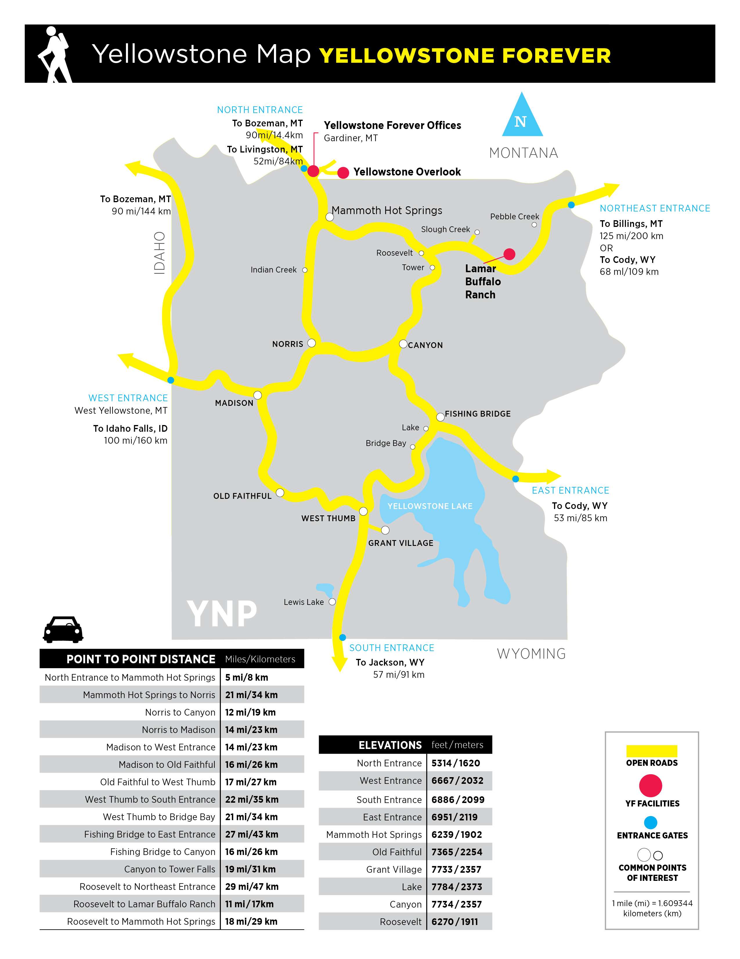

Plan on extra driving time in the park. The speed limit is 45 mph or lower. There may also be construction delays. Visit www.nps.gov/yell/planyourvisit/hours.htm, call the recorded NPS Road Report at 307.344.2117, or contact a visitor center for up-to-date travel information.

